Lab Title:week-11
JavaScript Registration Form Testing using Selenium

Objective:
To create a simple registration form using HTML and JavaScript, and perform automated functional testing using Selenium.

Step 1: Creating the Registration Form
- Open Visual Studio Code.
- Create a folder named RegistrationForm.
- Inside the folder, create a file named index.html with the following content:
- <!DOCTYPE html>
- <html lang="en">
- <head>
- <meta charset="UTF-8">
- <meta name="viewport" content="width=device-width, initial-scale=1.0">
- <title>Registration Form</title>
- <!-- Inline CSS -->
- <style>
- body {
- font-family: Arial, sans-serif;
- text-align: center;
- margin-top: 50px;
- background-color: #f5f5f5;
- }
- form {
- display: inline-block;
- text-align: left;
- background-color: #ffffff;
- padding: 20px;
- border-radius: 8px;
- box-shadow: 0 4px 8px rgba(0, 0, 0, 0.1);
- }
- input {
- width: 100%;
- padding: 10px;
- margin: 10px 0;
- box-sizing: border-box;
- border-radius: 4px;
- border: 1px solid #ccc;
- }
- button {
- background-color: #4CAF50;
- color: white;
- padding: 10px 20px;
- border: none;
- border-radius: 4px;
- cursor: pointer;
- }
- button:hover {
- background-color: #45a049;
- }
- #message {
- color: green;
- font-weight: bold;
- margin-top: 20px;
- }
- .error {
- color: red;
- }
- </style>
- </head>
- <body>
- <h2>Registration Form</h2>
- <!-- Registration Form -->
- <form id="registrationForm">
- <label for="username">Username:</label><br>
- <input type="text" id="username" name="username" placeholder="Enter username" required><br>

- <label for="email">Email:</label><br>
- <input type="email" id="email" name="email" placeholder="Enter email" required><br>

- <label for="password">Password:</label><br>
- <input type="password" id="password" name="password" placeholder="Enter password" required><br>

- <button type="submit">Register</button>
- </form>

- <!-- Message Display -->
- <p id="message"></p>

- <!-- Inline JavaScript -->
- <script>
- document.getElementById("registrationForm").addEventListener("submit", function(event) {
- event.preventDefault(); // Prevent form from submitting

- // Get input values
- const username = document.getElementById("username").value;
- const email = document.getElementById("email").value;
- const password = document.getElementById("password").value;
- constmessageElement = document.getElementById("message");
- // Validate inputs
- if (username === "" || email === "" || password === "") {
- messageElement.textContent = "All fields are required!";
- messageElement.classList.add("error");
- return;
- }
- // Check for valid email format
- constemailPattern = /^[^\s@]+@[^\s@]+\.[^\s@]+$/;
- if (!emailPattern.test(email)) {
- messageElement.textContent = "Invalid email format!";
- messageElement.classList.add("error");
- return;
- }
- // If all validations pass, show success message
- messageElement.textContent = "Registration Successful!";
- messageElement.classList.remove("error");
- messageElement.style.color = "green";

- // Clear the form
- document.getElementById("registrationForm").reset();
- });
- </script>
- </body>
- </html>
Step 2: Running the Web Application
- Open the terminal in Visual Studio Code
- Use the following command to start a simple HTTP server:
npx http-server
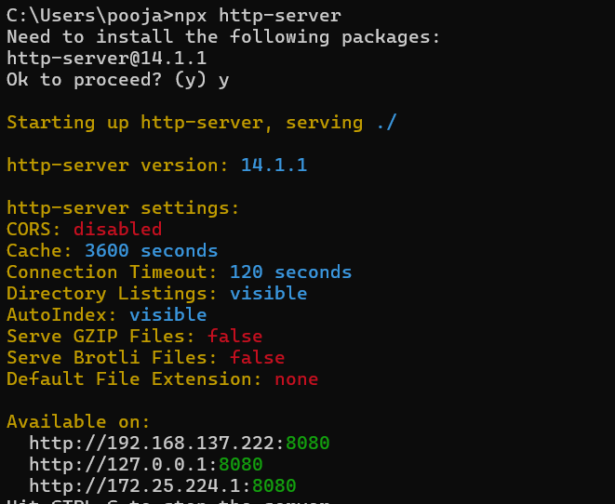
- Open your browser and go to http://localhost:8080 to view the form.
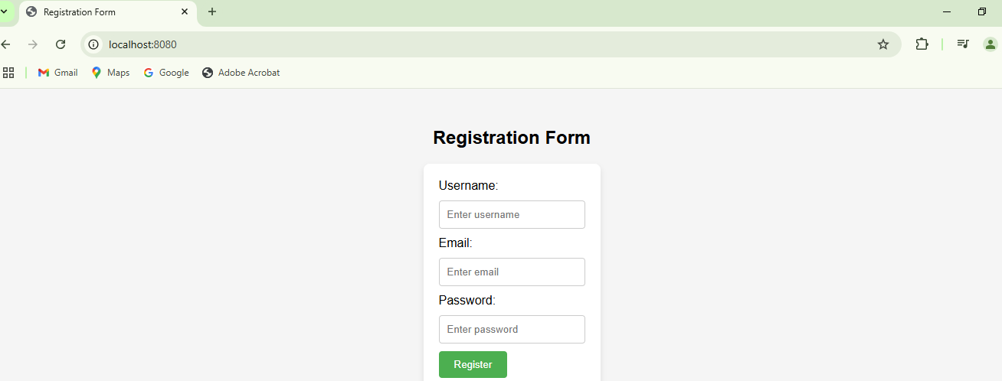

Part 2: Testing the Registration Form using Selenium
Step 1: Setting up Selenium in Node.js
- Initialize a Node.js project:
npm init -y
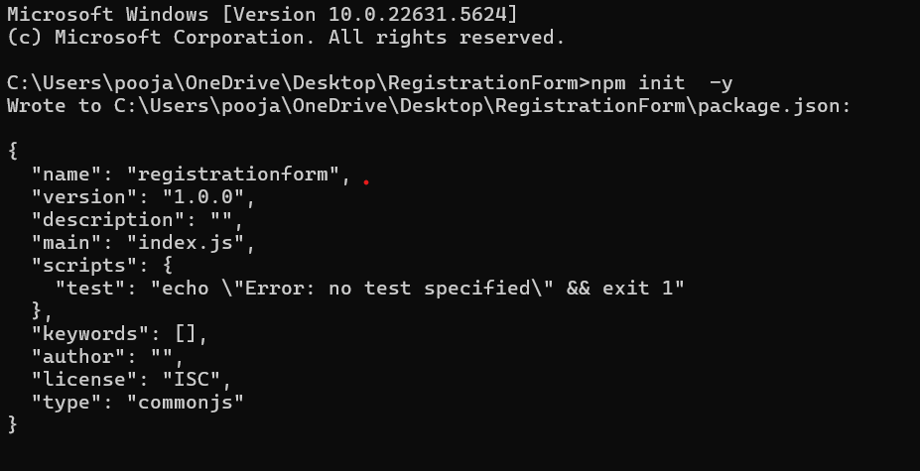
- Install the Selenium WebDriver package:
npm install selenium-webdriver
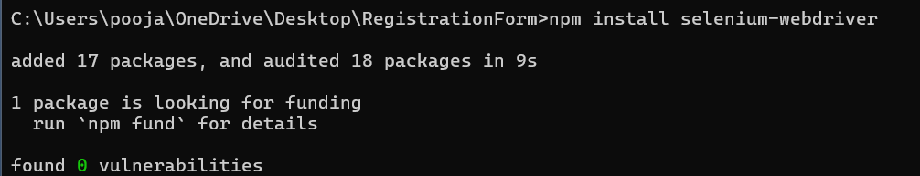
- Download the ChromeDriver that matches your Chrome browser version from ChromeDriver Downloads. “https://storage.googleapis.com/chrome-for-testing-public/141.0.7390.78/win64/chromedriver-win64.zip”
- Extract the downloaded chromedriver and place it in the project folder.
Step 2: Writing the Selenium Test Script
Create a file named test.js and add the following code:
javascript
Copy code
const{ Builder, By, Key, until } = require('selenium-webdriver');
async function testRegistrationForm() {
// Set up WebDriver
let driver = await new Builder().forBrowser('chrome').build();
try {
// Navigate to the registration form
await driver.get('http://localhost:8080');
// Enter username
await driver.findElement(By.id('username')).sendKeys('student1');
// Enter email
await driver.findElement(By.id('email')).sendKeys('student1@example.com');
// Enter password
await driver.findElement(By.id('password')).sendKeys('password123');
// Click the Register button
await driver.findElement(By.css('button[type="submit"]')).click();
// Wait for the success message to appear
await driver.wait(until.elementLocated(By.id('message')), 5000);
// Get the message text
let message = await driver.findElement(By.id('message')).getText();
console.log('Test Result:', message);
// Check if registration is successful
if (message === 'Registration Successful!') {
console.log('Test Passed');
} else {
console.log('Test Failed');
}
} finally {
// Close the browser
await driver.quit();
}
}

testRegistrationForm();

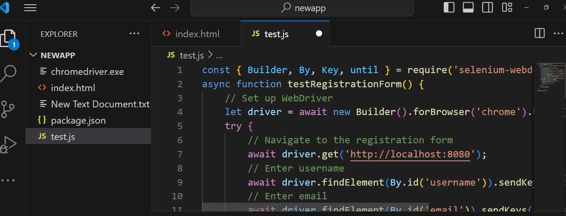

Step 3: Running the Selenium Test
- Ensure your HTTP server is running:
npx http-server
- Open a new terminal and run the Selenium test script:
node test.js

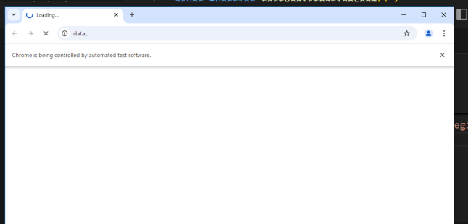

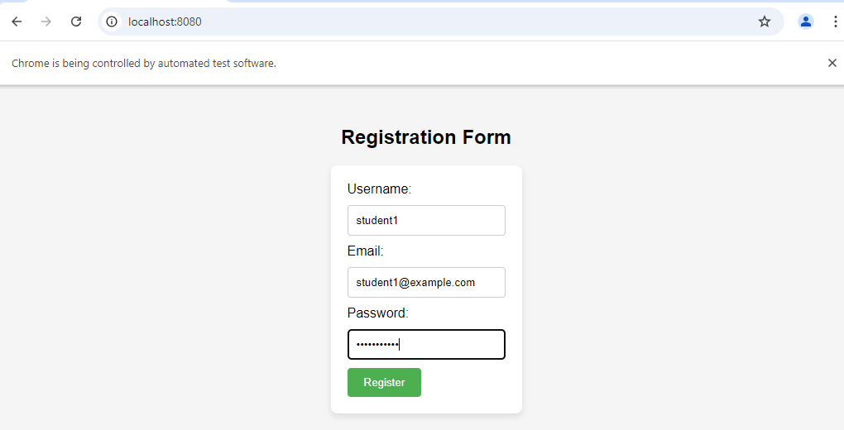

Expected Output:
The console should display:
Test Result: Registration Successful!
Test Passed
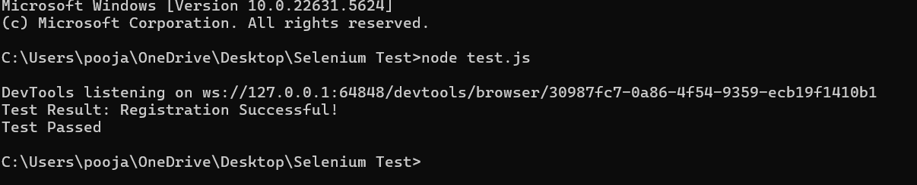
Step 4: Observations and Conclusion
- The automated test checks if the registration form functions correctly by filling in sample data and verifying the success message.
- If the form works as expected, the test will pass; otherwise, it will fail.

